System Requirements

Call-flow-Diagram

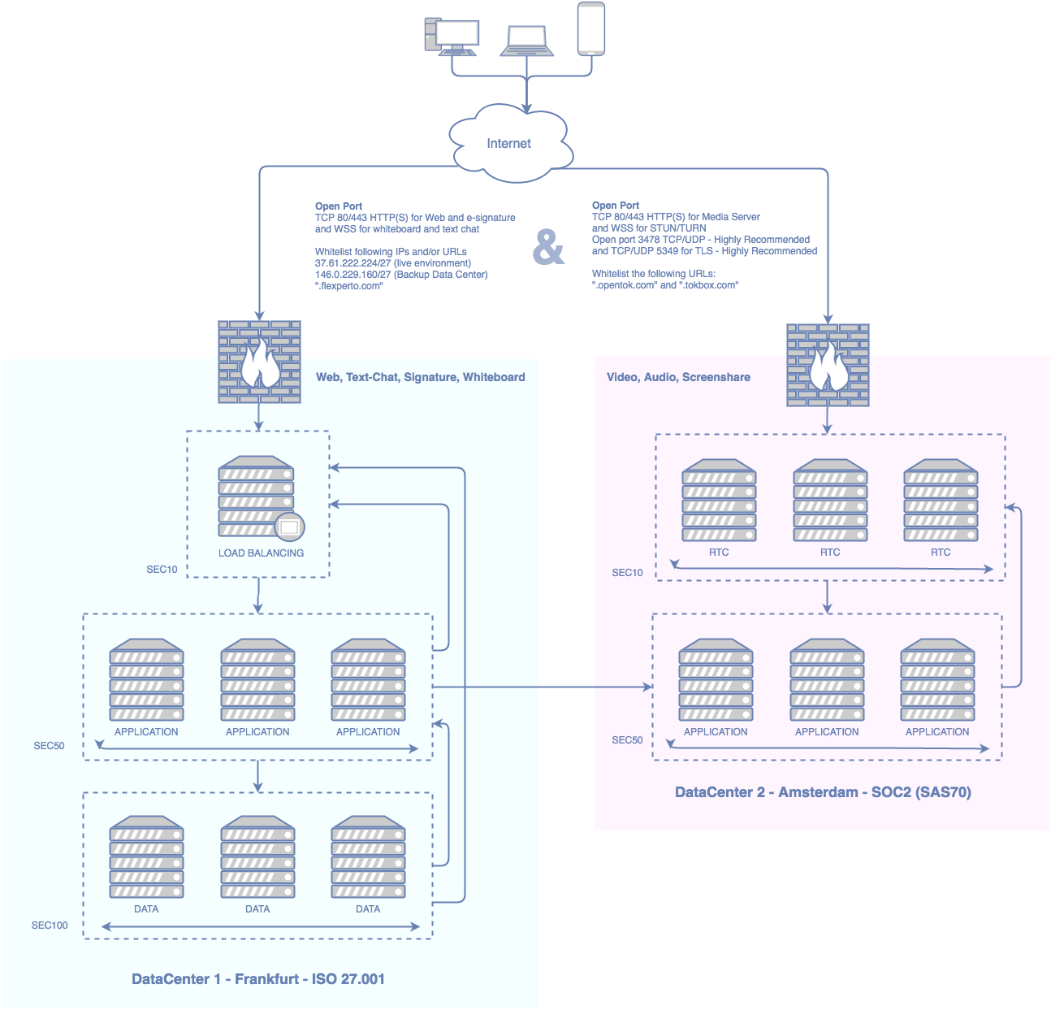

Network Requirements:
Using the Flexperto platform requires allowing access to its services over specific ports in order to work. A network administrator in your organization can configure these firewall settings.
Ports
Minimum Requirement:
The minimum Requirement is that TCP ports 80/443 HTTP(S) are open. Some firewall/proxy rules only allow for SSL traffic over port 443. You will need to make sure that non-web traffic can also pass over this port and that WSS (Proxy HTTP 1.1) can be used. In addition, due to browser limitations, you should configure your proxy to not require HTTP Basic Authentication when accessing URL's and IP's listed in the whitelist further down.

McAffee WebGateway
If you are using the McAffee WebGateway Proxy in version >= 7.2, "SSL inspection" on Port 443 has to be disabled for traffic towards the listed IPs and Domains further down. This is a known issue in the WebGateway: https://community.mcafee.com/thread/59536?tstart=0
In addition TCP/UDP port 3478 should be open. This connection is bidirectional but always initiated from the corporate network/client so it is not possible for an external entity to send malicious traffic in the opposite direction.
Without port TCP/UDP 3478 open and NAT/Proxies in place it is likely that the public facing NAT/Proxy IP can not be discovered and communication across the borders of the corporate network could fail.

Best Experience:
For the best possible experience, we recommend that TCP/UDP ports 5349 is open.
Whitelisting of IP’s and URL’s
The following IP’s must be whitelisted in any case:
IP | Description
37.61.222.224/27 | Network Connectivity - FX DC Main
146.0.229.160/27 | Network Connectivity - FX DC FailOver
95.172.85.0/25 | Network Connectivity - Streaming
64.95.96.0/25 | Network Connectivity - Streaming
35.158.127.224/28 | Network Connectivity - Streaming

The following domains must be whitelisted in any case
Domain | Description
flexperto.com | Platform - General connectivity
*.flexperto.com | Platform - General connectivity
*.*.flexperto.com | Platform - General connectivity
*.*.*.flexperto.com | Platform - General connectivity
ajax.googleapis.com/ajax/libs/jquery/* | CDN (Fonts, CSS, JS Libraries)
fonts.googleapis.com | CDN (Fonts, CSS, JS Libraries)
fonts.gstatic.com | CDN (Fonts, CSS, JS Libraries)
www.google.com/recaptcha/* | Frontend - Login Bot Challenge Protection
www.gstatic.com/recaptcha/* | Frontend - Login Bot Challenge Protection
*.opentok.com | Platform - Streaming connectivity
*.tokbox.com | Platform - Streaming connectivity
The following IP’s should be whitelisted:
IP | Description
all IPs included in https://whitelist.tokbox.com/whitelist.json | Platform - Global Streaming connectivity
The following Domains should be whitelisted:
Domain | Description
*.hotjar.com | Anonymous User Tracking (Hotjar)
api.mixpanel.com | Anonymous User Tracking (Mixpanel)
cdn.mxpnl.com | Anonymous User Tracking (Mixpanel)
*.gstatic.com | CDN (Fonts, CSS, JS Libraries)
*.ggpht.com | CDN (Fonts, CSS, JS Libraries)
*.googleapis.com | CDN (Fonts, CSS, JS Libraries)
www.google.com | CDN (Fonts, CSS, JS Libraries)
player.vimeo.com | Help Desk (Zendesk - embedded help video)
www.youtube-nocookie.com | Help Desk (Zendesk - embedded help video)
*.zopim.com | Help Desk (Zendesk)
assets.zendesk.com | Help Desk (Zendesk)
ekr.zdassets.com | Help Desk (Zendesk)
flexperto.zendesk.com | Help Desk (Zendesk)
static.zdassets.com | Help Desk (Zendesk)
notify.bugsnag.com | Fronted Anomaly Detection and Reporting
sentry.io | Fronted Anomaly Detection and Reporting

Calender Integration
Flexperto supports the integration of calendars that are hosted on Microsoft Exchange Servers (Office 365, managed or self-hosted), Outlook.com, iCloud and Google through our integration partner Cronofy.
If you use a Microsoft Exchange Server, please make sure that the following IPs have access to the Exchange Web Service interface (EWS):
- 54.93.34.174
- 3.121.21.226
- 3.122.2.191
For the best user experience we also recommend that autodiscover is turned on.
If you use Office 365, your administrator may have to whitelist the "Cronofy Connector" for your organisation. Please contact support@flexperto.com to obtain instructions on how to do this.

Client Side Requirements
Hardware
The client hardware should meet these minimum Requirements:
- Desktop or Laptop Computer, Android Tablet or Android Smartphone
- Processor: min 2 GHz Dual Core
- RAM: min 1 GB
- Web cam (integrated or external)
- Speakers (we recommend USB echo-canceling speakers for meeting room environments)
- Microphone (we recommend a headset with microphone for improved sound quality and privacy)
Software
The client software should meet these minimum requirements:
- Google Chrome Version 67 +
- Firefox Version ESR 60 +
- Firefox Version 60+
- Edge 17 (contained in Windows 10 April 2018 Update)
- Internet Explorer 11 (Plugin required)
- on Android Chrome 67 +
- on Android Firefox 60 +
- Safari 11+

Browser Settings
JavaScript must be activated.
Your camera must be accessible by and responsive to the browser. You can verify this via this test page https://simpl.info/getusermedia/
Things that can prohibit camera access are:
- For build in cameras: Your camera is deactivated in the BIOS-Settings
- For external cameras: Your PC is configured to not accept USB-Cameras
- Your camera driver is outdated (generally the universal Microsoft driver should work)
- Your Antivirus software (such as Avira or Kaspersky) is configured to block camera access by default
- Especially for Firefox: required features (such as getUserMedia or PeerConnection) are disabled in your browser
Browser Plugins
For broadcasting a screen (screensharing) in Chrome, a Flexperto browser plugin needs to be installed.
To receive a screen being shared, no plugin is required.
In order to interoperate with Safari Browsers (namely using the on this platform only supported h264 codec) Firefox requires a build in Plugin "openh264" to be up to date. In enterprise environment, Firefox is typically configured to not perform automatic updates. Due to the plugin system of Firefox, this causes that openh264 files are out of date. For Safari Support find here a patch which updates the plugin files of Firefox without using Firefox Auto Update features. The archive contains a README with detailed instructions on how to apply the patch: https://flexperto.box.com/s/ctzl7whdgedi05bqzwyeyprqahape28m
Screensharing (broadcasting) doesn't work on mobile OS Systems. (Android and IOS) Tokbox doesn't support this feature.
Firefox with updated disabled and Safari Support
In order to interoperate with Safari Browsers (namely using the on this platform only supported h264 codec) Firefox requires a build in Plugin "openh264" to be up to date. In enterprise environment, Firefox is typically configured to not perform automatic updates. Due to the plugin system of Firefox, this causes that openh264 files are out of date. For Safari Support find here a patch which updates the plugin files of Firefox without using Firefox Auto Update features. The archive contains a README with detailed instructions on how to apply the patch:
https://flexperto.box.com/s/ctzl7whdgedi05bqzwyeyprqahape28m
Screensharing Mobile OS
Screensharing (broadcasting) doesn't work on mobile OS Systems. (Android and IOS )
Tokbox doesn't support this feature.

IE11 Machine Level Installation
Usage of flexperto on IE11 requires a Plugin Installation. The Platform will automatically attempt a Plugin installation for any user browsing our Meeting Room on IE11. This self-service Plugin installation requires admin level permissions on the client. In case your employees are not equipped with admin level permissions and you do operate a central software provisioning service for your clients, you can install the IE11 Plugin on machine level. The installers are:
for 64 bit systems: https://static.opentok.com/v2/plugin/OpenTokPluginMain_x64.msi
for 32 bit systems: https://static.opentok.com/v2/plugin/OpenTokPluginMain_x32.msi
Operating System
The following Operating Systems are supported:
- OSX10.9+
- Windows 8.1 +
- Ubuntu 12 +
- Android KitKat +
  - with Chrome 67 +
  - with Firefox 60 +
Thin Clients
Thin Clients are not supported.
Internet Bandwidth
We recommend a minimum dedicated 1.000 kb/s down per downloaded stream, as well as 1.000 kb/s up per uploaded stream to maintain a stable video / audio connection. Please note that the bandwidth is not the only factor for a stable video / audio connection.

Date: February 26th, 2019

